Brigham Young University -- Idaho

The Grand Canyon  
Discovering History

Joshua Jolley

Geology 111L

Sister Megan Pickard

March 24th, 2016

# INTRODUCTION

The Grand Canyon is one of the United States’ 58 national parks and is found in Arizona along the Colorado River. (National Park Service, 2016). The canyon itself is 446 km long and over 29 km wide at some points. (National Park Service, 2016) The Colorado River has cut a path that is 1.6km deep in some places. (National Park Service, 2016) According to Google maps, the map coordinates of the Grand Canyon are 36.1000° N, 112.1000° W. The Grand Canyon is an American symbol, and an important part of American culture. This paper will discuss the geologic history of the canyon, the prevailing theories on the development of the canyon itself, and the impacts of the Colorado dam on the site.

# GEOLOGIC HISTORY

## Overview

From the Kaibab limestone to the Vishnu Schist, The Grand Canyon tells a story of the past that covers billions of years, and gives us insight into the geological processes that have occurred in that time frame. There are 25 distinct rock layers and two unconformities that this paper will discuss. Their names and ages are: Vishnu Schist & Zoraster Granite (1.7 - 2.0ga); the Pre-Cambrian unconformity; the Unkar Group (1.1-1.25ga), which includes the Bass Formation (1.25ga), Hakatai Shale (1.2ga), Shinumo Quartzite (1.2ga), Dox Sandstone (1.19ga), and the Cardenas Lavas; Nankoweap Formation (1.05ga); the Chuar Group (825 - 1000 ma) which includes the Galeros Formation, Kwagunt Formation, and the Sixtymile Formation; the Great Unconformity; the Tonto Group (515 - 545ma) which includes the Tapeats Sandstone (545ma), Bright Angel Shale (530ma), and the Muav Limestone 515ma; Temple Butte Limestone (350ma); Redwall Limestone (335ma); Supai Formation (285ma); Hermit Shale (265ma); Coconino Sandstone (260ma); Toroweap Formation 225ma; and last but not least, the Kaibab Limestone (250ma). (Ribokas, 1994) Whew! That was a long list. As we delve into each layer and its related details, see the included images to get a feel for each layer. Particularly review Figure 1 as it provides an excellent overview of the whole canyon and can help prevent losing the forest for the trees. (See Figure 1).

|  |
| --- |
| https://lh3.googleusercontent.com/UnO-JIHn3_Oa_VnpTulBP6HXd7tf0sy4LYrBgIWxR-mFYQtis6PnKYnjSk6xDCzBTwIgihMIIVYH_o9SiimpVan2Oj73wbR-qKQSMQo9ZErCb2vuAzSfSidxi84MWistyP5RDmlj  Figure 1 – Grand Canyon Stratification |

## Geologic Time

Before discussing the geologic history of the Grand Canyon, it is important to learn a few terms relating to geologic time. Throughout the paper you will see letters ma, and ga appended to numbers. The a stands for annus, which is 365.25 days. Ma is megaannus, which is one million years. Ga is gigaannus, which is one billion years.

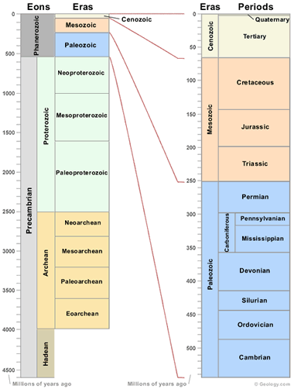Geologists use a time scale that is divided into 6 classes of times: Supereons, Eons, Eras, Periods, Epochs, and Ages. Supereons are the largest class, and there is only one of them, namely, the Precambrian supereon. This is everything older than the Cambrian period, which started 541 ma ago. Each unit encapsulates several of the following unit inside of it, for example the Cenozoic era includes the Quaternary, Neogene, and Paleogene periods. Eras are one to three ma long. Periods are ten to one hundred ma. Epochs are tens of ma, and Ages are only a few ma long. Refer to this image in order to see where a particular time unit fits into the past. (See Figure 2)

Figure 2 – Geologic Time Scale

## Vishnu Schist & Zoraster Granite 1.7 - 2.0 ga

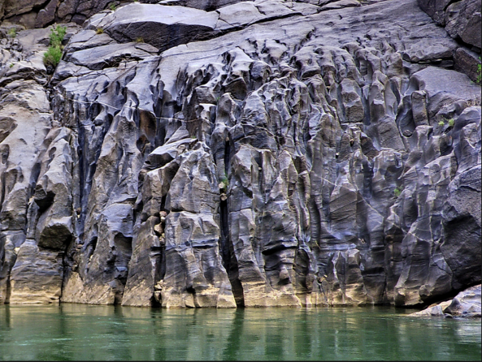In the Precambrian supereon, roughly 2 ga ago, a volcanic island collided with what became North America. (Timmons, 2003) This collision subducted the ocean basin along the coast and metamorphosed the floor into schist and gneiss. (Timmons, 2003) The Vishnu schist can be picked out along the canyon as it is the closest rock layer to the water, and has a distinct, dark color. (See Figure 3) The canyon walls made of Vishnu schist are often quite steep due to their erosion resistance. (Timmons, 2003) The Vishnu schist found here is a mica schist metamorphosed from sandstone, limestone and shale.(Ribokas, 1994)

Figure 3 – Vishnu Schist

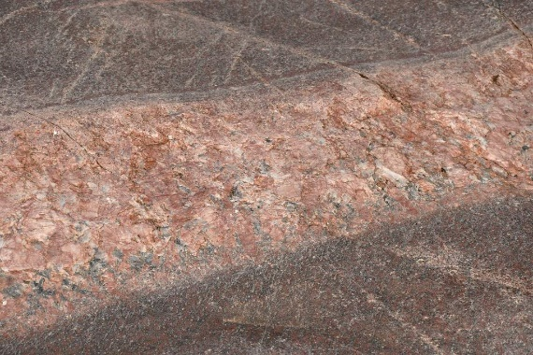A few hundred ma later, the Zoraster granite found in the canyon intruded the Vishnu schist in many places. Bands of pink granite can be found throughout the Precambrian basement rock along the Grand Canyon. (Timmons, 2003)

Figure 4 – Zoraster Granite

## Precambrian unconformity

There is a gap of 600 million years in the rock layers of the Grand Canyon. This unconformity is thought to be caused by the erosion of mountains that formed during this time back into a plain. (Ribokas, 1994) It’s amazing that Mother Nature can wipe out 600 ma of history and leave hardly a trace in the rock record.

## Unkar Group 1.1-1.25 ga

The Unkar group is the first rock group in what is commonly referred to as the Grand Canyon Supergroup. (Timmons, 2003) Several less significant unconformities are found in this group, some of them covering millions of years. (Timmons, 2003)

* 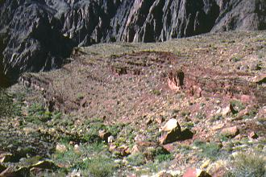**Bass Formation**   
  Clocking in at 1.25 ga, the Bass Formation consists of limestone and some shale. (Ribokas, 1994) It can be identified by its grey color.(Ribokas, 1994)

Figure 5 – Bass Formation

* 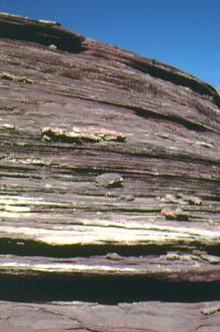**Hakatai Shale**

There is thought to be no time gap between the Bass Formation and the Hakatai Shale. Aged at 1.2ga the Hakatai Shale and the Bass Formation have been dated by the presence of stromatolites in the rock. (Ribokas, 1994) Fossil records like the stromatolites are important for dating sedimentary rocks as our usual dating methods usually give the age of the rock that created the sediment rather than the sedimentary rock itself. (Timmons, 2003)

Figure 6 – Hakatai Shale

* 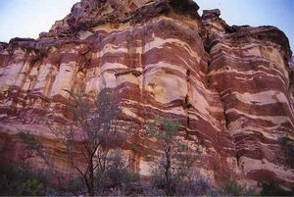**Shinumo Quartzite**

A few million years are missing between the Hakatai Shale and the Shinumo Quartzite layers. This layer is rarely visible in the canyon, but is quite beautiful. (See Figure 7)(Ribokas, 1994)

Figure 7 – Shinumo Quartzite

* 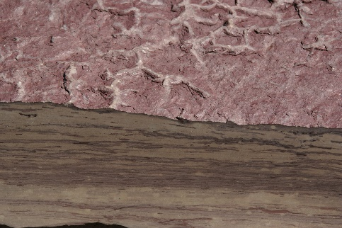**Dox Sandstone**   
  Forming at roughly the same time as the Shinumo Quartzie, the Dox Sandstone is mostly sandstone, but also some shale.(Ribokas, 1994) Unlike the other rocks in this layer, it contains fossilized algae. (Ribokas, 1994)

Figure 8 – Dox Sandstone

* 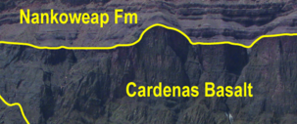**Cardenas Basalt**   
  These basaltic lava flows are dark brown in color. (Ribokas, 1994)

Figure 9 – Cardenas Lavas and Nankoweap Formation

## Nankoweap Formation 1.05 ga

The Nankoweap formation occurs only on the eastern part of the canyon. (Ribokas, 1994) It has unconformities both above and below it. (Ribokas, 1994)

## Chuar Group 825 - 1000 ma

Only 1 ga back in history, the Chuar group contains three formations. It is the last rock layer before the great unconformity. Sources vary in their dating of this formation, some placing it from 770 to 740 ma, and others much further back.

* 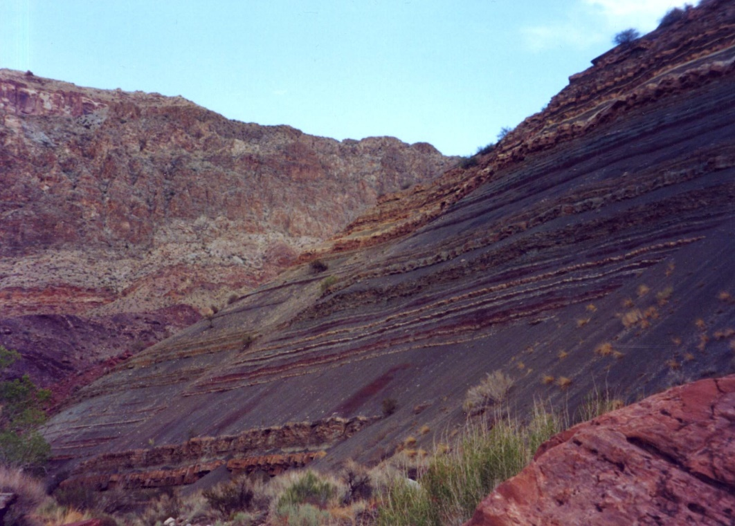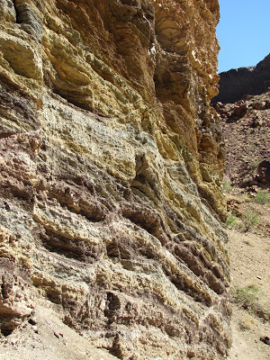**Galeros Formation**  
  The Galeros Formation contains several rock types, including limestone, sandstone, and shale. (Ribokas, 1994)

Figure 10 – Galeros Formation

* **Kwagunt Formation**  
  The Kwagunt Formation contains mudstone, shale, limestone, and in places, sandstone. (Ribokas, 1994)

Figure 11 – Kwagunt Formation

* 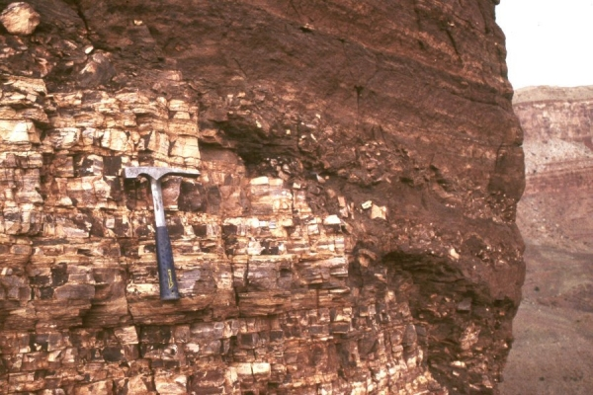**Sixtymile Formation**

The Sixtymile formation is rarely exposed in the canyon. It is composed of sandstone and shale.(Ribokas, 1994)

Figure 12 – Sixtymile Formation

## Great Unconformity

Depending on where in the canyon you find it, the Great Unconformity represents a gap of up to 1.2 ga, where the Vishnu Schist is in contact with the Tapeats Sandstone. (Ribokas, 1994) The exact cause of the Great Unconformity is unknown.

## Tonto Group 515 - 545ma

The Tonto group contains the Tapeats Sandstone, the Bright Angel Shale, and the Muav Limestone. In some places, this rock group rests directly on the basement rock, due to the Great Unconformity. (Hereford, 1977) The Tonto Group spans between 515 – 545 ma, marking a roughly 300 ma gap from the Chuar group.

* **Tapeats Sandstone**The Tapeats are part of the basal sandstone the spreads across western and central Arizona. (Hereford, 1977) This layer rarely contains fossils, and is as wide at 80m at some points. (Hereford, 1977) The Tapeats were deposited as shelves along the cordilleran miogeosyncline. (Hereford, 1977) The Tapeats are a coarse-grained sandstone that contain ripple marks from the waves of an early Cambrian sea and is dark brown in color. (Ribokas, 1994) This sandstone was formed 545 ma ago. (Ribokas, 1994)
* **Bright Angel Shale**The Bright Angel Shale is easily eroded, spreading its green, grey, and brown sediment along the canyon walls. (Ribokas, 1994) The shale was deposited as a sea floor that was previously thought of as a salt water sea, but new evidence is being found to suggest that it was a fresh water sea.(Baldwin et al, 2004) Triolobites and brachiopods are frequently found in this layer. (Ribokas, 1994) This layer is 530 ma old. (Ribokas, 1994)
* **Muav Limestone**The Muav Limestone spreads to north up into Utah.(Wood, 1966) While deposited by a sea like the Angel Shale, it appears that the sea that deposited this rock layer contained salt water as opposed to the fresh water of the previous layer. (Wood, 1966) Ah, what 15 ma can do to an area. More prevalent on the western side of the Grand Canyon, it is a grey color. (Ribokas, 1994) This layer is 515 ma old. (Ribokas, 1994)

## Temple Butte Limestone 350ma

The Temple Butte Formation, like the two previous layers, was deposited by the sea. (Timmons, 2003) As its name suggests, it is mostly limestone. It also contains some dolomite, sandstone and siltstone. (Timmons, 2003) It is grey in color. Note the roughly 130 year gap in the rock record between the Muav Limestone and the Temple Butte Limestone. (Timmons, 2003)

## Redwall Limestone 335ma

Unlike the popular book series by the same name, you will find no fuzzy little mammals in this rock layer. What you will find are clams, snails, corals, fish, and trilobites, fossilized forever. (Ribokas, 1994) This limestone is primarily marine in origin. (Ribokas, 1994) The trickery in the name ends there, as the Redwall Limestone layer is indeed Red.(Timmons, 2003) It was deposited in the Missisipean Period. (Timmons, 2003) This layer is absolutely littered with caves. It is supposed that the limestone was the groundwater system of the time. (Timmons, 2003)

## Supai Formation 285ma

The Supai Formation is made of shale, but has a layer of sandstone over the top. (Ribokas, 1994) This feature has many amphibians, reptiles and plants in the fossil record on the east end. (Ribokas, 1994) The fossil record transitions to marine life as you move to the western side of the canyon. (Ribokas, 1994)

## Hermit Shale 265ma

The Hermit Shale, unlike the many layers previous to it, was deposited at least in part by wind. (Timmons, 2003) Like the Bright Angel Shale, this layer erodes easily and has spread its sediment down the canyon. (Ribokas, 1994) The Hermit shale is red. (Ribokas, 1994)

## Coconino Sandstone 260ma

The Coconino Sandstone is made of quartz sand. (Ribokas, 1994) This layer is white colored. (Ribokas, 1994) This layer is nicknamed the bath-tub ring because of its obvious resemblance to one. (Timmons, 2003) This layer contains the trace fossils of foot prints of animals that lived at that time. (Timmons, 2003)

## Toroweap Formation 225 ~ 270ma

Depending on the source you find, the Toroweap Formation began between 225 to 270 ma ago. (Timmons, 2003) The formation is primarily limestone and sandstone. (Timmons, 2003) The layer ranges in color from yellow to grey.(Ribokas, 1994)

## Kaibab Limestone 250ma

The top and final layer of the Grand Canyon is the Kaibab Limestone. This layer is primarily limestone, but also contains a lot of chert. (Timmons, 2003) There are brachiopods, coral, sea lilies, mollusks, worms and fish teeth fossils found in this layer. (Ribokas, 1994)

# CANYON DEVELOPMENT

The development of the Grand Canyon is a hotly debated topic in geology. (Ranney, 2014) There are two large groups of thought, one for the ‘old canyon’ and one for the ‘young canyon’.(Ranney, 2014) Since a symposium on the topic held in 1964, there have been three additional large meetings where papers, people and ideas came together to attempt and resolve this debate. (Ranney, 2014) The original postulation for the incision history of the Grand Canyon was that the Colorado River began incision at the beginning of the Late Cretaceous period, roughly 100 ma ago. (Ranney, 2014) Don Elston was the main proponent of this theory. (Ranney, 2014) Many geologists of the day disagreed on the grounds that there were no diagnostic pebble clasts in the Muddy Creek Formation. (Ranney, 2014) At the time, Ivo Lucchitta argued for a young canyon model. (Ranney, 2014) His model proposed that the Colorado River was no older than latest Miocene, roughly five to six ma ago. (Ranney, 2014) The importance of the Muddy Creek Formation was explored by Chester Longwell, who during his exploration of the region did not find the expected sediment in Muddy Creek that should have been there if there were a river upstream eroding the rocks further up the canyon.(Ranney, 2014) Due to this find, he stated that it was impossible that the Colorado River was present during the Muddy Creek time, as there should have been round pebbles created by the stream, and he could find none.(Ranney, 2014) As the Muddy Creek formation was dated at 6ma ago, this discovery, which was labeled the Muddy Creek problem, challenged Elstons claims for an old canyon and started the debate that continues until today. (Ranney, 2014) Two years ago, Young and Crow came forward with a paper detailing how the Colorado River could not have formed in the Late Cretaceous period due to the stratigraphic record of the area. (Young and Crow, 2014) Instead, all evidence they found pointed towards the river forming in the late Miocene or early Pliocene. (Young and Crow, 2014) Also two years ago, Hill and Polyak studied the Kaibab uplift and proposed that karst piracy was the method that brought the Colorado river together five to six ma ago. (Hill and Polyak, 2014)Last year, Abbot, Lundstrom and Traub submitted a paper recognizing this debate while also recognizing the consensus of the geologic community regarding the convergence of the drainage streams into what we now know of as the integrated Colorado River five to six ma ago. (Abbott, Lundstrom and Traub, 2015) They propose that a transient knickzone (a broad, area causing an increase or decrese in the height of the river at the lowest point a river can incise) caused a massive slowdown of the incision rate of the Grand Canyon 0.4 ma ago. (Abbott, Lundstrom and Traub, 2015) Their finds contradict the findings of old canyon proponent’s million year incision ideas. (Abbott, Lundstrom and Traub, 2015)

# IMPACT OF COLORADO RIVER DAMS

One of the impacts of the Boulder/Hoover Dam was that many rocks related to the development of the Colorado River, and thus the Grand Canyon, are now buried under the reservoir. (Ranney, 2014) In 1964 while the dam was still under construction geologists were anxious to study the area before they lost their ability to do so. (Ranney, 2014) As we have previously explored, in 1964 geologists had not come to a consensus on the age of the Colorado River. (Ranney, 2014) Chester Longwell, a geologist and student of Yale at the time, wrote: “One of the major unsolved problems of the region is the date of origin of the river itself . . . Geologists who have no direct acquaintance with the region will be at a loss to understand so wide a divergence in interpretation” (Ranney, 2014) It’s hard to estimate or measure the setback of the dam on geological studies related to the incision of the canyon. Perhaps they key to understanding was hidden in the reservoir and could have been discovered decades earlier. More likely, the impact was small, as newer understanding and dating techniques are needed to coax the history of the incision of the dam from the rocks.`

The other, and more pressing, impact of dams along the Colorado are the ecological impacts of the colder, cleaner water being put into the river by the dams. (USGS, 2008) The Glen Canyon Institute states that over 95% of the sediment that was once flowed through the canyon has been stopped by the Glen Canyon Dam. It further states that several species of fish, including the Colorado Pikeminnow and the Bonytail Chub, have gone extinct due the Dam. USGS reports that a third native species, the Colorado squawfish, has disappeared from the river. (USGS, 2008) It is believed that backwater channels, a natural habitat for the fish, were filled in due to a lack of yearly flooding. The sediment loss has caused a 10 foot difference in daily river levels and has caused a net loss of sand from sandbars and campsites along the river. (USGS, 2008) The dam also has reduced the regular flow of the river. Normally, each year there was a flood of the Grand Canyon, flushing fragment through the canyon at speeds up to 100,000 cubic feet per second. (USGS, 2008) Since the dam, the max flow of water was 30,000 cubic feet per second. (USGS, 2008) This has caused a buildup of rocks and builders at the tributary mouths, which causes river rapids to become more dangerous. (USGS, 2008) The Glen Canyon Institute also reports that the Humpback Chub has population has been reduced from over 5000 to less than 1100 fish, again, directly as a result of the dam. USGS reports that the water, sediment, fish population, riparian vegetation, and Native American cultural and archeological sites have been altered by the Glen Canyon Dam. (USGS, 2008) One positive of impact from the Glen Canyon dam is the creation of a habitat suitable for trout, making thousands of river runners happy. (USGS, 2008) Other negative impacts include the loss of camping beaches (USGS, 2008) Two controlled floods have been released into the canyon in an attempt to restore the beaches, but according to the Glen Canyon Institute, the benefits conferred by these floods are temporary. (USGS, 2008) The flooding does hope to clean out the backwater channels mentioned earlier. (USGS, 2008) Another potential positive impact of the Glen Canyon Dam was the reintroduction of vegetation near the river. (USGS, 2008) Over 1,000 acres of habitable land was created when the yearly floods were stopped from scouring the vegetation from the river banks. (USGS, 2008) Part of this land is marshland, which wasn’t there before the dam. (USGS, 2008) The new ecological environment in the canyon creates a diversity of life not found before the construction of the dam. (USGS, 2008) Another minor benefit is that bald eagles now frequent the canyon due to the increased trout population. (USGS, 2008) Before the dam, eagles only passed through the canyon, rather than staying and visiting.

# CONCLUSION

This paper has reviewed the geologic history of the Grand Canyon, including its many rock layers, reviewed the hotly debated method of the creation of the Grand Canyon, and discussed the many, impacts of damming along the Colorado River on the Grand Canyon. This region of America has a rich geologic history and even after centuries of study, there are still mysteries to be solved regarding the many layers, the exact nature of the incision, and what the final impacts of the dam will be.

# REFERENCES

Abbott, L.D., Lundstrom, C., and Traub, C., 2015, Rates of river incision and scarp retreat in eastern and central Grand Canyon over the past half million years; evidence for passage of a transient knickzone: Geosphere [Boulder, CO], v. Pre-Issue Publication, , doi: 10.1130/GES00978.1.

Baldwin, C.T., Strother, P.K., Beck, J.H., and Rose, E., 2004, Palaeoecology of the Bright Angel Shale in the eastern Grand Canyon, Arizona, USA, incorporating sedimentological, ichnological and palynological data: Geological Society Special Publications, v. 228, p. 213-236.

Hereford, R., 1977, Deposition of the Tapeats Sandstone (Cambrian) in central Arizona: Geological Society of America Bulletin, v. 88, p. 199-211.

Hill, C.A., and Polyak, V.J., 2014, Karst piracy; a mechanism for integrating the Colorado River across the Kaibab uplift, Grand Canyon, Arizona, USA: Geosphere, v. Pre-Issue Publication, , doi: 10.1130/GES00940.1.

Ranney, W., 2014, A pre-21st century history of ideas on the origin of the Grand Canyon: Geosphere, v. 10, p. 233-242, doi: 10.1130/GES00960.1.

Ribokas, B., 1994, Grand Canyon Rock Layers: (<http://www.bobspixels.com/kaibab.org/geology/gc_layer.htm>3/19 2016).

Timmons, S., 2003, Grand Canyon Geology Training Manual: (<http://www.nps.gov/grca/naturescience/geology_manual.htm>3/19 2016).

USGS, 2008, https://walrus.wr.usgs.gov/grandcan/grandcan.pdf

Wood, W.H., 1966, Facies changes in the Cambrian Muav Limestone, Arizona: Geological Society of America Bulletin, v. 77, p. 1235-1245, doi: 10.1130/0016-7606(1966)77[1235:FCITCM]2.0.CO;2.

Young, R.A., and Crow, R., 2014, Paleogene Grand Canyon incompatible with Tertiary paleogeography and stratigraphy: Geosphere, v. Pre-Issue Publication, , doi: 10.1130/GES00973.1.

**Images**

Figure 1 - <http://www.bobspixels.com/kaibab.org/geology/gc_layer.gif>  
Figure 2 - <http://geology.com/time/geologic-time-scale-380.gif>

Figure 3 - <https://www.flickr.com/photos/alanenglish/3599021827>

Figure 4 - <http://www.kaibab.org/kaibab.org/tr081/lg_oct_16_2008_115818.jpg>

Figure 5 - <http://www.rockhounds.com/grand_hikes/images/formations/gc9_1.jpg>

Figure 6 - <http://www.rockhounds.com/grand_hikes/images/formations/gc9_14.jpg>

Figure 7 - <http://i.colnect.net/images/f/835/038/Grand-Canyon-Mile-1338-Shinumo-Quartzite-at-Tapeats-Creek.jpg>

Figure 8 - <https://upload.wikimedia.org/wikipedia/commons/f/f9/2012.09.14.120943_Dox_sandstone_Yavapai_Point_Grand_Canyon_Arizona.jpg\>

Figure 9 - <http://intheplaygroundofgiants.com/wp-content/uploads/2014/09/Figure-7.-The-Cardenas-Basalt-Nankoweap-Formation-and-Galeros-Formation-exposed-within-the-Tanner-Graben-copyrighted.jpg>

Figure 10 - <http://3.bp.blogspot.com/_F2O1UdcXyPg/TMICrUDLAbI/AAAAAAAAAcQ/ERbhlEQ1gRE/s400/0958CarbonateGalerosFormationHighlyColoured_IMG_1989.JPG>

Figure 11 - <http://images.summitpost.org/original/250276.jpg>

Figure 12 - <http://www.usu.edu/geo/dehler/60mile21.jpg>